Unit 1

* 1. Microscopic techniques

**Terminology:**

* Principle:
  + Microscopy is to get a magnifies image, in which structures may be resolved which could not be resolved with the help of an unaided eye
* Magnification:
  + Ratio of “size of object seen under microscope” to “size of object seen with naked eye”
  + Calculated as “Magnifying power of lens” * “magnifying power of eye piece”
* Resolving power
  + Ability to differentiate two close points as separate
  + Human: 0.25 mili meter
  + Light microscope: 0.25 micro meter
  + Electron microscope: 0.5 nano meter
* Limit of resolution
  + Minimum distance between two points that can be identified separately
  + Abbe equation
  + 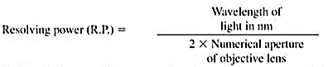
  + Limit of resolution inversely proportional to power of resolution.
  + Short wavelength = greater resolution
* Working distance
  + Distance between objective (lens?) and objective slide
  + Distance decreases, magnification increases
* Numerical aperture
  + Ratio of “Diameter of lens” to “focal length of lens”

**Light microscope**

* + History:
    - 1590 - F.H. Janssen & Z. Janssen - simple compound light microscope
    - 1665 - Robert Hooke – laboratory microscope
    - Kepler & Galileo – modern class room microscope
    - 1672 – Leeuwenhoek – Simple microscope (200x-300x magnification) – father of microscopy
    - 1623 – Faber – coined term microscope
* Diagram of Light microscope
  + - 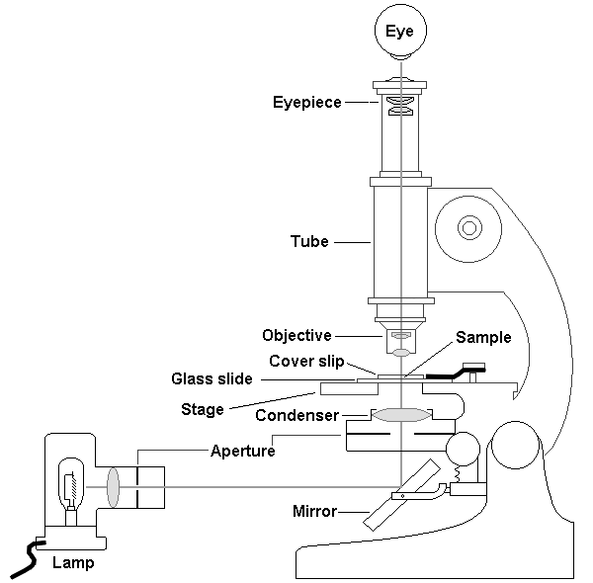
* Parts of light microscope (bottom to top)
* Base – supports microscope
* Illuminator – light source
* Iris diaphragm – adjust light going in condenser
* Condenser – focuses light
* Stage – platform to hold specimen
* Objective – lens directly above stage
* Nosepiece - Holds objective
* Coarse focusing knob – wide focus adjustment
* Fine focusing knob – small focus adjustment
* Ocular eyepiece – lens on top magnification of 10x
* Body – microscope body
* Difference between low power, high power and oil immersion microscope

|  |  |  |  |
| --- | --- | --- | --- |
| Characteristic | Low | High | Oil immersion |
| Magnification of objective | 10x | 40-45x | 90=100x |
| Total Magnification | 100x | 400x-450x | 900x-1000x |
| Numerical aperture | 0.25-0.30 | 0.55-0.65 | 1.25-1.4 |
| Mirror | Concave | Concave | Plane |
| Focal length | 16mm | 4mm | 1.8-2mm |
| Working distance | 4-8 mm | 0.5-0.7 mm | 0.1mm |
| Iris diaphragm | Partially closed | Partially open | Fully open |
| Position of condenser | Lowest | Slightly raised | Fully raised |
| Maximum resolution | 0.9 micro meter | 0.35 micro meter | 0.18 micro meter |

* Used as common multipurpose microscope for live, preserved, stained specimens. Provides fair cellular detail

**Dark field microscope**

* Adapted from light microscope by adding a “stop” to the condenser
* Stops all light except peripheral light – this light is reflected on sides of the specimen.
* Resulting image is bright specimen surrounded by dark field
* Used for observing live, unstained specimens. Provides outline of specimen with reduced internal cellular detail

**Phase contrast microscope**

* History:
  + 1935 – F. Zernike
* Uses special condenser
* Condenser splits light beam and throws them slightly out of phase
* Separated beams pass through and around specimen
* Small differences in refractive index of specimen show up as different degree of brightness and contrast
* Used for live specimens, excellent for internal cellular detail

**Fluorescence microscope**

* Developed by Haitinger and Coons
* Uses mercury vapor arc lamp as light source
* Darkfield condenser used
* 3 sets of filters used to alter light that passes through
* Specimen should be coated with special compound that can fluoresce (fluorochromes)
* Used to study specimens stained with fluorescent dye. Specificity makes it a diagnostic tool

**Electron microscope**

* 1932 – Knoll and Ruska
* Uses beam of electrons instead of visible light
* Magnified image visible on fluorescent screen – recorded on photographic film
* Images are always black and white
* Two general forms: TEM and SEM (transmission and scanning)
* TEM:
  + Used to view specimens under very high magnification, only on preserved material
  + Specimen is sectioned into 20-100 nm thick slices and coated with metals
  + Transmits electrons through specimen
  + Dark areas represent thicker parts light area represent less dense parks
* SEM:
  + Used to view external surface of specimen, produces 3D image
  + Specimen is placed in vacuum chamber and coated with thin layer of gold
  + Electrons are bounced on specimen line by line and an image is built
  + Sloping surfaces yield fewer electrons, making them darker and giving the specimen a 3D sense
  + Resolving power is 10 nm. Magnification is 20,000x

**Difference between light and electron microscope**

|  |  |  |
| --- | --- | --- |
| **Characteristic** | **Light** | **Electron** |
| Useful magnification | 2000x | 1 million x |
| Maximum resolution | 200 nm | 0.5 nm |
| Image produced | Visible light | Electron beam |
| Image focused | Glass objective | Electromagnetic objective |
| Image viewed | Glass ocular lens | Fluorescent screen |
| Specimen placed | Glass slide | Copper mesh |
| Specimen alive | Yes | No |
| Specimen stained | Not always | Yes |
| Colored images | Yes | No |

* 1. **centrifugation**

**Definition:**

* Process used to separate or concentrate materials suspended in liquid, based on effect of gravity.
* Two particles with different masses will settle in a tube at different rates in response to gravity
* Separates 2 immiscible liquids
* More dense – away from axis. Less dense – towards axis
* Involves centrifugal force for sedimentation of heterogenous mixtures

**Principle**

* Centrifuge puts an object in rotation around a fixed axis applying force perpendicular to axis of spin
* Using sedimentation principle, denser substances move outward and lighter are displaced inward

**Instrumentation**

* Two components
  + Electric motor to spin
  + Rotor to hold tubes

**Low speed centrifuge**

* Standard
* 4000-5000 rpm
* Operates at room temperature (no temp control)
* Fixed angle / swinging bucket rotors are used
* Sedimentation of red blood cells

**High speed centrifuge**

* Used in sophisticated biochemical applications
* High speed and temp control for sensitive biological sample
* Fixed angle, swinging bucked and vertical rotors are used

**Ultra centrifuge**

* Most sophisticated
* Spinning chamber is cooled and kept at high vacuum
* Used for prep and analytical work

**What is a rotor**

* It’s the rotating unit of centrifuge (duh)
* It has fixed holes to place test tubes
* Swing bucket rotor
  + Sample ranges from 36 mL to 2.2 mL in volume
  + Preferred for rate-zonal separations
  + Distance between outside of meniscus and outside of bottom is long enough
* Fixed angle rotor
  + Sample ranges from 0.2mL to 1mL
  + Preferred for pelleting
  + K factor indicates how efficient a rotor can be at max speed.
  + Lower K factor, higher pelleting efficiency
* Vertical rotor
  + Highly specialized
  + Used to band DNA in cesium chloride
  + They have very low K actor
  + Runtime is short

**Types of centrifugation techniques**

* Density Gradient
  + Allows separation of many or all components in mixture
  + Rate zonal
    - Solution has density gradient. Sample has density greater than all solution layers
    - Sample is applied in thin zone at top of centrifuge tube.
    - Under centrifugal force particles will sediment based on shape and density
  + Isopycnic / sedimentation equilibrium centrifugation
    - Solution contains greater range of densities
    - Each particle will sediment to position in centrifuge at which gradient density is equal to its own
    - Separation occurs in zones on basis of their density differences
* Differential centrifugation
  + Commonly used in microbiology and cytology
  + Tissue sample is homogenized
  + Homogenate is subjected to repeated centrifugations, removing pellet, increasing centrifugal force
* Ultra centrifugation
  + Svedberg used it to determine the MW and subunit structure of hemoglobin
  + First commercial was in 1940 by SPINCO

**Calculation of centrifugal force**

* Opposing force to centripetal force

**Calculation of angular velocity**

* Rate of change of angular displacement
* It is a vector quantity
* Specifies angular speed of an object and the axis about which the object is rotating
* SI unit is radians per second
* Represented by omega symbol (ω)
* Rate of change of angular displacement of particle in given time is called angular velocity
* Angular displacement 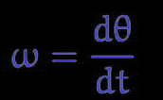 where D theta is change in angular displacement and D t is change in time
* Angular velocity 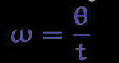 where theta is angular displacement and t is time
* Linear velocity 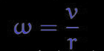 where V is linear velocity and r is radius of circular path

**Applications o centrifugation**

* Used in water treatment for separation of heavy particles, oily sludge and solid subances
* Removing fat from milk to produce skimmed milk
* Clarification and stabilization of wine
* Separation of urine and blood components in forensic and research laboratory

**Electrophoresis**

* Migration of charged particle under influence of electric field
* Many important biological molecules possess ionizable groups and therefor in ay pH exist as electrically charged species
* Particles migrate to either cathode or anode in electric field depending on nature of their charge
* Rate of migration depends on
  + Strength of electric field, size and shape
  + Hydrophobicity of sample
  + Ionic strength and temp of buffer
  + Molecular size of sample
  + Net charge of sample
  + Shape of sample
* Large molecules = slower movement | small molecules = faster movement

**Electrophoretic mobility**

* Rate of migration
*  where myu = electrophoretic mobility | Q = net charge of ion | r – Ionic radius | lund n = viscosity of medium

**AGE:**

* Involves use of agarose gel as supporting media
* Most commonly used form of electrophoresis
* Principle
  + Electric field is applied across electrophoretic tank containing agarose gel
  + Loaded biomolecules get separated on the basis of their size, and affinity to their electrodes
  + Agarose gel works as a sieve. Particles smaller than the pore size pass through where are large particles stay behind
* Application
  + Separation of digested DNA, gDNA
  + Analysis of PCR products
  + Estimation of size of DNA molecules using DNA marker or ladder
  + Estimation of DNA quantity (lambda DNA ladder) quality (observing absence of streaking)
  + DNA fingerprinting
* Advantages:
  + Ease of setup
  + Does not denature samples
  + Samples can be recovered
* Disadvantages
  + Gels can melt
  + Buffer can become exhausted
  + Different genetic material may run in unpredictable pattern

**SDS PAGE**

* Sodium dodcyl sulphate polyacrylamide gel electrophoresis
* Used to separate proteins on size
* Principle
  + Uses anionic detergent Sodium dodecyl sulfate to dissociate proteins into their individual polypeptide subunits and gives uniform negative charge along each denatured polypeptide
  + Forces polypeptides to achieve similar charge:mass ratio
  + Vertical gel apparatus is used
* Application
  + Establishin protein size
  + Protein identification
  + Checking sample purity
  + Identifying disulfide bonds
  + Blotting applications
* Advantages
  + Mobility is high and separation is rapid
  + Protiens are negatively charged : all migrate toward anode
  + SDS solubilizes all proteins : hydrophobic / dentured

**Difference between AGE & PAGE**

|  |  |
| --- | --- |
| **AGE** | **SDS PAGE** |
| Separates on the basis of charge of the molecules | Separates on the basis of mass of molecules |
| Can be horizontal or vertical | Always vertically |
| Separation according to charge and size | Separation according to mass and charge |
| Low resolution | Higher resolution |
| Includes both denaturing and non denaturing techniques | Denatures proteins prior to separation |

**2D electrophoresis**

* Used for analysis of complex protein mixtures extracted from cells, tissues or other biological samples
* Separates thousands of proteins simultaneously
* Separates in 2 steps
  + 1st dimension is isoelectric focusing. Separates according to their isoelectric points
  + 2nd dimension is SDS PAGE which separates on basis of molecular weights
* Each spot potentially corresponds to single protein species
* 1st dimension
  + In a pH gradient under the influence of electric field, a given protein will move to a position where its net charge is 0
  + Protein with net positive will migrate towards cathode, net negative will migrate towards anode
  + This is the focusing effect which allows proteins to be separated on basis of very small charge differences
  + Isoelectric point is a pH at which a protein has neutral charge
  + Separation on the basis of pI not MW
  + Requires high voltages (10000v)
  + Long time (9-12h)
  + Resolution depends on pH gradient slope
* 2nd dimension
  + The second dimension is regular sds page where the separated strip is then separated further in a perpendicular direction.
  + SDS operates on the principle that smaller particles will travel faster towards the anode whereas bigger will hang back
  + Since in SDS the protein is denatured and coated evenly with a negative charge he separation is purely on the basis of their molecular weight
  + Separation on basis of MW not pI
  + Requires modest voltage (200v)
  + Short time (2h)
  + Resolution depends on %acrylamide and electric field strength
* Applications:
  + Protein cataloguing
  + Protein quantification
  + Protein species and isoform distribution analysis
  + Quality control of proteins and antibody
* Advantages:
  + High throughput
  + High resolution
  + Various computer based tools are available
  + Cost efficient
  + Flexible
* Disadvantages
  + Large amount of sample handling
  + Limited reproducibility
  + Similar dynamic range as other methods

**Isoelectric focusing**

* Separation technique in which molecules are separated based on their isoelectric point
* Isoelectric point is the pH at which the net charge of protein is 0
* If the number of acidic groups in a protein exceeds the number of basic groups, pI of the protein is acidic
* If the number of basic groups in a protein exceeds the number of acidic groups, pl of the protein is basic
* Carries ampholytes are low molecular weight moleculaes that help in creating a stable pH gradient
* Properties of ampholytes should be:
  + Soluble in water
  + Low adsorption spectra
  + Behave as a behave and offer conductance ( wtf does that mean)
* Protein sample is loaded on a pH gradient and high voltage is applied
* The proteins then travel to their pI. i.e. the point at which their et charge is 0 and then stay there.
* This is then blotted to calculate the pH of the bad obtained. A standar curve is obtained and pI value is calculated
* Applications
  + Used for separation and identification of serum proteins
  + Food, agricultural industries, forensic and human genetic laboratories
  + Enzymology, immunology
  + As the first part of 2D gel electrophoresis

**Beer – lambert law**

* When a monochromatic light of initial intensity passes through a solution, some of the light is absorbed so that the intensity of the transmitted light is less than initial intensity.
* The relationship between initial and transmitted intensity depends on the path length of the absorbing medium and the concentration of the solution
* Lamberts law
  + When a ray of monochromatic light passes through an absorbing medium its intensity decreases exponentially as the length of the absorbing medium increases
  + 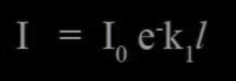
* Beer’s law
  + When a monochromatic light passes through an absorbing medium its intensity decreases exponentially as the concentration of the absorbing medium increases
  + 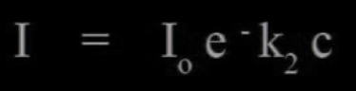
* These two combined are
  + 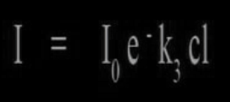
* Transmittance
  + Ratio of intensities is known as transmittance
  + 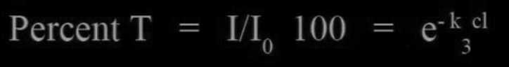
* Extinction
  + If logarithms are taken of the equation instead of a ratio then
  + 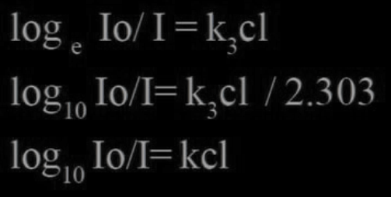
* If beer-lamberts law is obeyed correctly, then a plot of extinction against concentration gives a straight line passing through the origin

**Unit 4**

**HPLC**

* Type of modified column chromatography
* In column chromatography the column is coated with an adsorbent material (silica) and mobile phase is passed down due to gravity
* But in HPLC the column is attached with a high pressure pump (40MP)
* Column is coated with an adsorbent material that has very small particle size giving us large surface area and high resolution
* Components
  + Column
    - Stainlessteel column that can withstand high pressures (50MP)
    - Length can vary from 5cm – 25ccm, internal diameter is 4.5mm
    - Flow rate trhough the column is 1-3ml/min
  + Stationary phase
    - Adsorbent material
    - Small particle size
    - Silica, divinly benzene
  + Mobile phase
    - Mxture of different solvents is used as mobile phase
    - Solvent depends on type of molecules that need to be separated
    - Can be polar or non polar
  + Solvent is connected to the comlumn with a high pressure pump
  + Sample injector lies between the pump and the complumn to introduce our sample into the column
  + A detector is attached to the bottom of the column to detect the separation
  + Uv, IR, refractive index, mass spectrometry detectros are used and a graph is plotted against time
  + This graph is the compared against graphs obtained by standard runs and the components of a solution are determined
  + Concentration of the molecule is determined by calculation AUC. AUC increases with increase in concentration
* Normal phase HPLC
  + Polar stationary phase, non polar mobile phase
* Reverse phase HPLC
  + Polar mobile phase, non polar stationary phase
* Size exclusion HPLC
  + Stationary phase is porus making small molecules travel slower compared to large molecules that donot get stuck in the pores
* Ion exchange HPLC
  + Stationary phase has ionic charge
  + Separation occurs based on the molecular charge

**HPTLC**

* High performance thin layer chromatography is automated high throughput form of TLC
* Analytical method used for bother qualitative and quantitative analytical tasks
* Works on the principle of adsorption
  + Which states that the solute having more affinity towards the stationary phase will travel slower
  + The component having less affinity to stationary phase will travel faster

**TLC**

* Simplest fastest and easiest chromatographic technique
* It consists of
  + Mobile phase (developing solvent)
  + Stationary phase (plate or strip coated with a form of silica gel)
* Can be defined as method of separation or identification of a mixture of components into individual components by using finely divided adsorbent solid spread over a glass plate and liquid as mobile phase
* Based on the principle of adsorption chromatography where the component which has more affinity towards stationary phase travels slower, whereas the component which has less affinity towards stationary phase travels faster
* Parameter that describes migration is R values
* R = distance travelled by solute / distance travelled by solvent front
* Factors affecting this are
  + Mobile phase
  + Thickness of layer
  + Temperature
  + Dipping zone
  + Loading
  + Nature of adsorbent

**Difference between HPTLC and TLC**

|  |  |
| --- | --- |
| **TLC** | **HPTLC** |
| Plate is sometimes handmade sometimes pre coated | Plate is always pre coated |
| Adsorbent layer is 250 micro meter thick | Adsorbent layer is 100 to 200 micrometer thick |
| Plates are not prewashed (removal o impurities from stationary phase using dipping methods in methanol:chloroform solutions) | Plates are prewashed |
| Application of sample is manual | Sample application is automatic |
| Shape is spot | Shape is pot or band |
| Low efficiency | High efficiency |
| Slow analysis lime | Grately reduced analysis time |
| Development chamber requires higher amount of solvent | Development chamber requires lower amount of solvet |
| Spot size is 2-4mm | Spot size is 0.5-1mm |
| Scanning is not possible | Scanning is done using UV/ visible/ fluorescence scanner |

**Adsorption chromatography**

* A technique in which separation of solutes is based on their adsorption to the stationary phase
* It is suited for non-polar small compounds
* One advantage of adsorption chromatography is that it is able to retain some compounds that can not be separated by other methods

**Partition chromatography**

* This is a chromatographic technique in which solute are separated on the basis of their partition between a liquid mobile phase and a liquid stationary phase coated on a solid support
* Support material is usually silica

**Ion exchange chromatography**

* It is a liquid chromatography technique in which solutes are separated by their adsorption on to a support containing fixed charge on its surface
* It is a fairly common technique used in water softeners and in the industrial removal and replacement of ionic compounds for products

**Affinity chromatography**

* Who the fuck knows

**Turbidimetry and nephelometry**

* In nephelometry, intensity of scattered light is measured
* In turbidimetry, intensity of light transmitted through the medium (un-scattered light) is measure
* Difference between

|  |  |
| --- | --- |
| **Nephelometry** | **Turbidimetry** |
| Mercury arch lamp | Tu/Du lamp |
| Rectangular cuvette used | Semi octagonal cuvette |
| Scattered light is measured | Ligth tramitted is measured |
| Measured at 90 deg | Measured in a straight line |
| Detector is PMT | Detector is photocell |
|  |  |

**Difference between IR and raman spectroscopy**

|  |  |
| --- | --- |
| **RAMAN** | **IR** |
| Result from scattering of light by vibrating molecules | Result from light absorption by vibration molecules |
| Results in change of polarizability | Results in change of dipole moment |
| Monochromatic light beam of high intensity / visible /infrared can be used | Limited to monochromatic beam of infrared light |
| Scattered light is observed at right angles to incident beam | Absorption is measured in the same direction as incident beam |
| It is nondestructive for the sample | It requires sample preparation using KBr hence it is destructive |